2

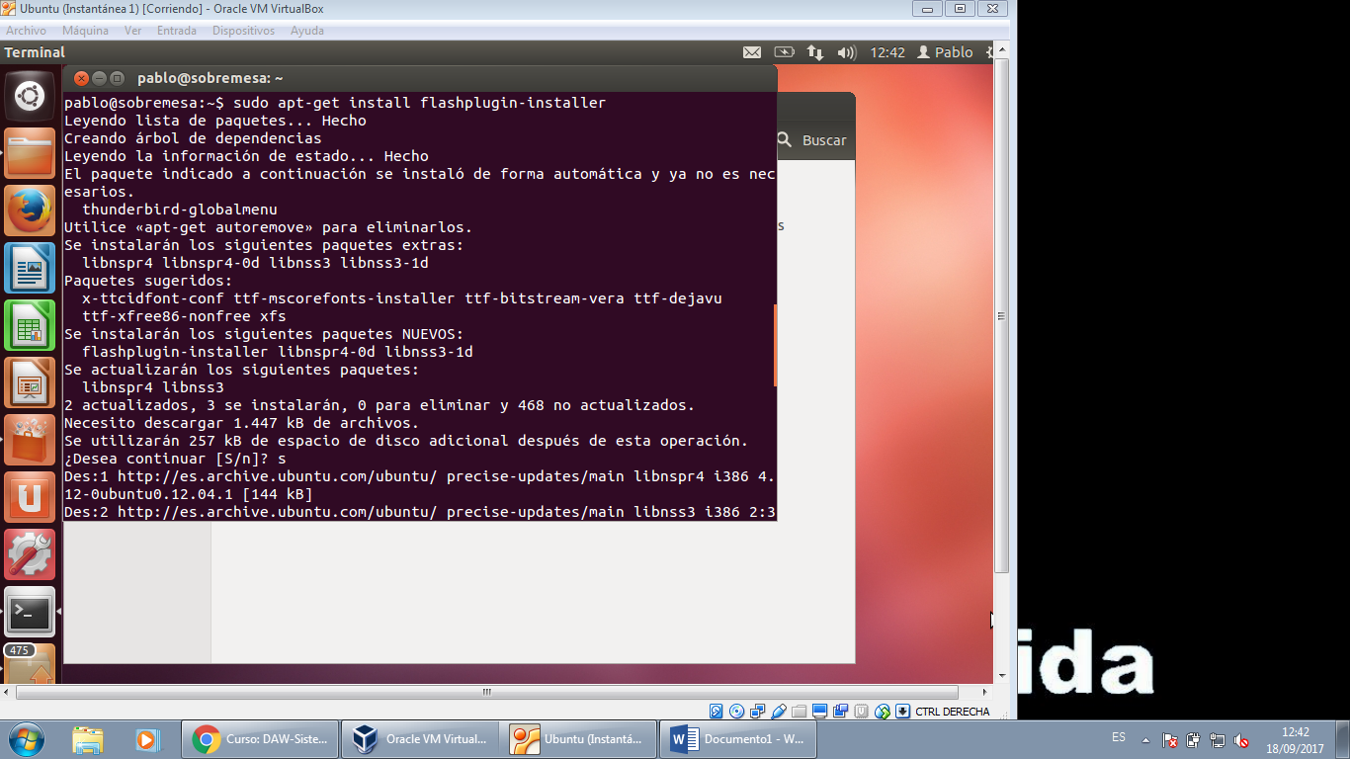

3

Sudo apt-get install libjpeg62

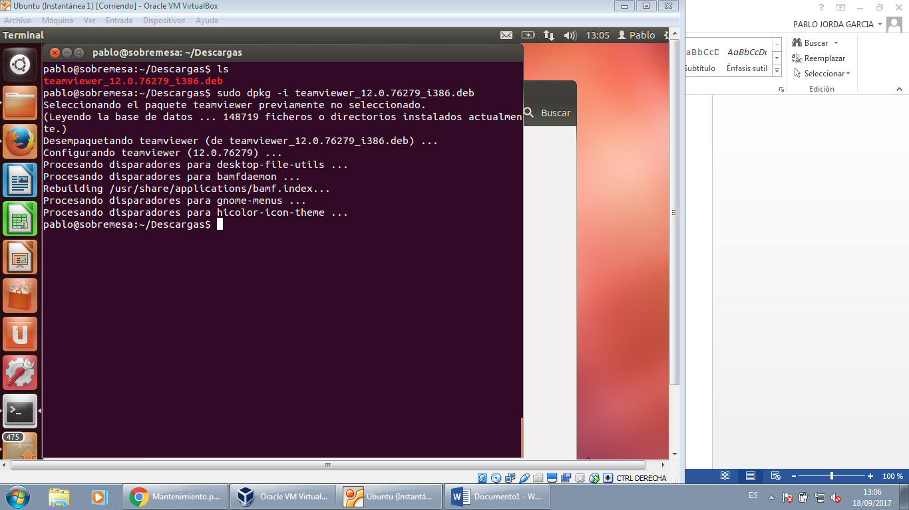

4 sudo apt-get remove

5 desde Descargas/ tar –xzvf emacs-25.2.tar.gz para descomprimir

./configure (no funciona)

Instalar librerías xorg-dev libjpeg-dev libpng-dev libgif-dev libtiff-dev autoconf automake libgconf2-dev libgpm-dev libtool libdbus-1-dev libgtk2.0-dev libm17n-dev libncurses-dev libotf-dev librsvg2-dev libXpm-dev texinfo

./configure

Make

Sudo Make install

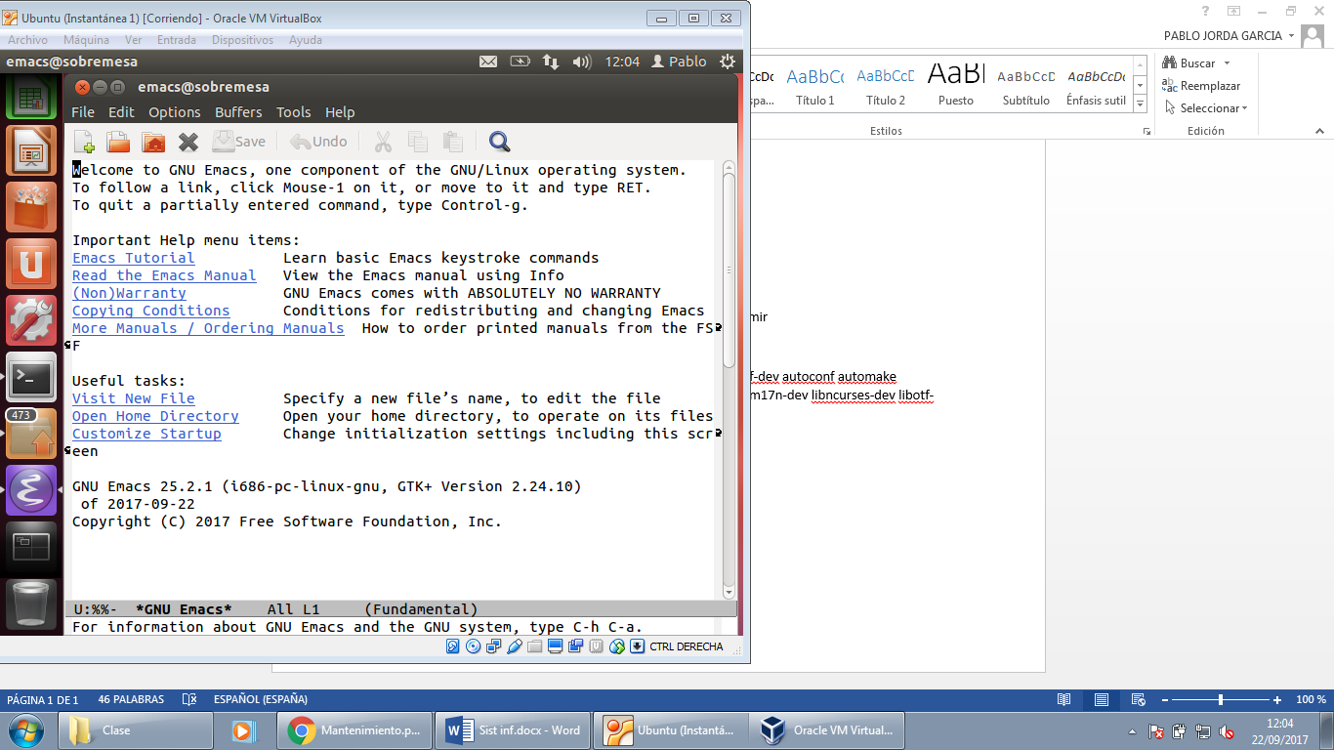

6

Instalar el jdk: sudo add-apt-repository ppa:webupd8team/java

sudo apt-get update

sudo apt-get install oracle-java8-installer

Descargar y descomprimir el eclipse: tar –xzvf eclipse-jee-oxygen-R-linux-gtk.tar.gz

Ejecutar el instalador: ./eclipse

